21-Aug-2020

**Background:**

Adyen is a payment processing company based out of the Netherlands. It predominantly operates in the enterprise space and its client list includes some of the world’s most well-known brands such as Netflix, Facebook, Uber, and Spotify. Adyen supports over 145 currencies and dozens of payment methods. In 2019 the company processed Euro 239.6 billion in transactions, 51% higher than in 2018.

**History:**

The company was started in 2006 by a team led by Pieter van der Does (current CEO) and Arnout Schuijff (current CTO). The team had come from Bibit (which they founded), another Dutch payments company which was sold to Worldpay in 2004. Adyen was founded with the goal of re-building the payments ecosystem which was laced with legacy systems and caused about 1 in 10 online payments to be rejected[1]. Not only were payments rejected but data was lost between systems that were not well integrated. The issues are highlighted in their IPO prospectus through this passage *“Fragmentation of the value chain across geographies and channels. In a typical card transaction, it is not uncommon for multiple independent organizations to be involved for the completion of the transaction. This problem is further compounded for large global organizations which must deal with multiple payment partners and integrate with all of them. Even when a single organization claims to be providing the full service globally, they have constructed the payment solution using numerous systems, which can result in some of the same problems as dealing with multiple providers also resulting in multiple integrations.”*

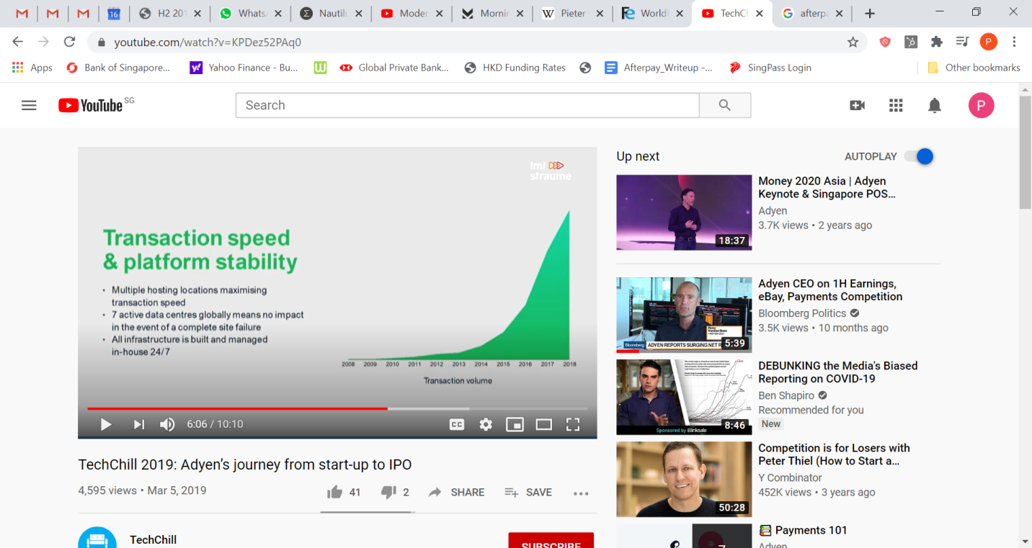The company initially started in Europe and initially started to work more on the data reconciliation and reporting aspect of payments. They were self-admittedly trying a number of things in the market to see what would work and what solutions fit. Eventually they found a groove processing payments as a technical gateway (ie customer still had to have contracts with other parties like an acquiring bank). But in 2011 they were granted a Visa/MasterCard acquiring license which allowed them to essentially offer a full-stack solution to their customers which required just 1 contract and 1 integration. Adyen claim that their full-stack solution (where they provide an end-to-end solution) is 73% of their volume[2]. The business really took off after this (you can see transaction volume growth on the chart on the left) and in 2011 they achieved profitability for the first time. The company reached unicorn status in 2014 and went public in June 2018, with the stock soaring 90% during its first day of trading.

**Tech Difference:**

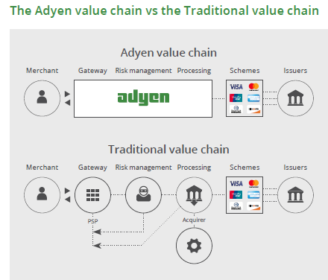They key difference between legacy payment systems and what Adyen builds is wrapped around the concept of a ‘full-stack’ system. To explain this, Adyen has a few illustrations on their site that are very helpful. The chart below shows that Adyen’s tech-stack allows it roll a number of roles (gateway, processor, acquirer) into one. This makes life very simple for a merchant who no longer needs to look for a payment gateway and an acquiring bank and can simply just plug-in Adyen onto their site (or use one of their PoS systems for physical retail), create an account and be good to go. The company also has a number of API’s which allow merchants to integrate with ecommerce systems. Adyen’s goal is to “Accept Payments Anywhere” and thus their stack is built to achieve this. As an acquirer they may also have to host or hold payments for a period of time, and thus they have a banking license in the EU to handle such situations.   
  
As a side note, this complexity that we’re referring to in the payment space is why companies like Adyen exist. Every country payments process and infrastructure are quite unique, some countries have quite tyrannical laws relating to payments (ie India does not allow the charging of the merchant discount rate[3]). John Collison, the co-founder of Stripe recently on a podcast stated about the industry, “The first thing you have to step back and realize is just how crazy, inefficient, and immature payments on the internet still are… the system for economic exchange (on the internet) are highly complex, heterogeneous, and increasingly fracturing or fractured.”[4]

**Unit Economics:**

Like any payment processing company, Adyen makes a percentage of each transaction that flows through their system. They charge the merchant a payment method fee, which is a percentage of the transaction. Now anyone who has studied payments knows that the payment method is variable, and is mostly made up of interchange fees. Interchange fees are set by the network (Visa/Mastercard) but paid to the issuer[5]. Interchange fees are notoriously opaque, and every country has their own regulation, and different card types have their own fees (for example in the US debit card fees are fixed, but credit cards are not). Just to put it in perspective, read this disclaimer on Adyen’s website *“Note: US credit is unregulated and US debit applies to regulated banks only. Fee caps only apply to consumer cards in the US and EU. And, in Mexico, caps depend on industry and some rates are negotiable.”*

So to make things simper, for Visa/Mastercard payments, Adyen charges an Interchange++ fee which is variable as regulation changes (ie if the EU brings down this fee, the merchant will get the benefit). The Interchange++ fee is made up of the interchange fee, the scheme fee that goes to Visa/MC (the first ‘+’) and the acquirer fee (the second ‘+’). Since Adyen is the acquirer they end up capturing this portion of the fee. Adyen also charges processing fees, which are fixed amounts (~US$ 12cents). The Payment method fees do vary based on the credit card/payment type used, and more details can be seen [here](https://www.adyen.com/pricing?gclid=Cj0KCQjw9b_4BRCMARIsADMUIyrD4wnGhGBoYbJIcL5KMUspJmYJK9UFNYm51S6KGNWEJWFYaPpTfV4aArmoEALw_wcB) as Adyen openly publishes their rates.

With regards to what is recorded as revenues, Adyen records a settlement fee (which they earn for acquiring and gateway services), and all off the processing fees. However as shown, shown in the ecosystem illustration above there are many players within the payment ecosystem that all need to be paid for their service (ie Networks like Visa/MasterCard as well as the issuing bank). So below we will take you through the unit economics, based on 2019 numbers.

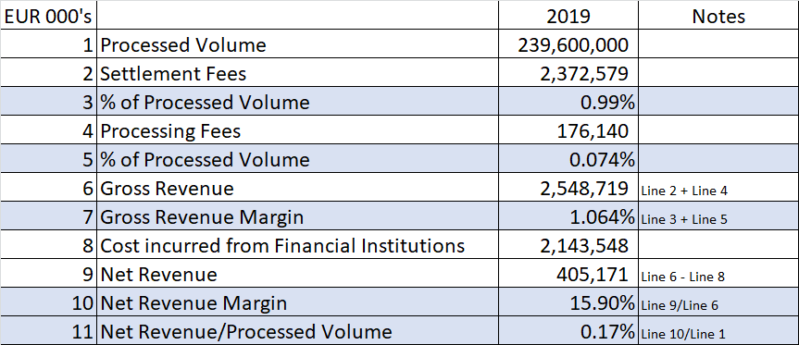

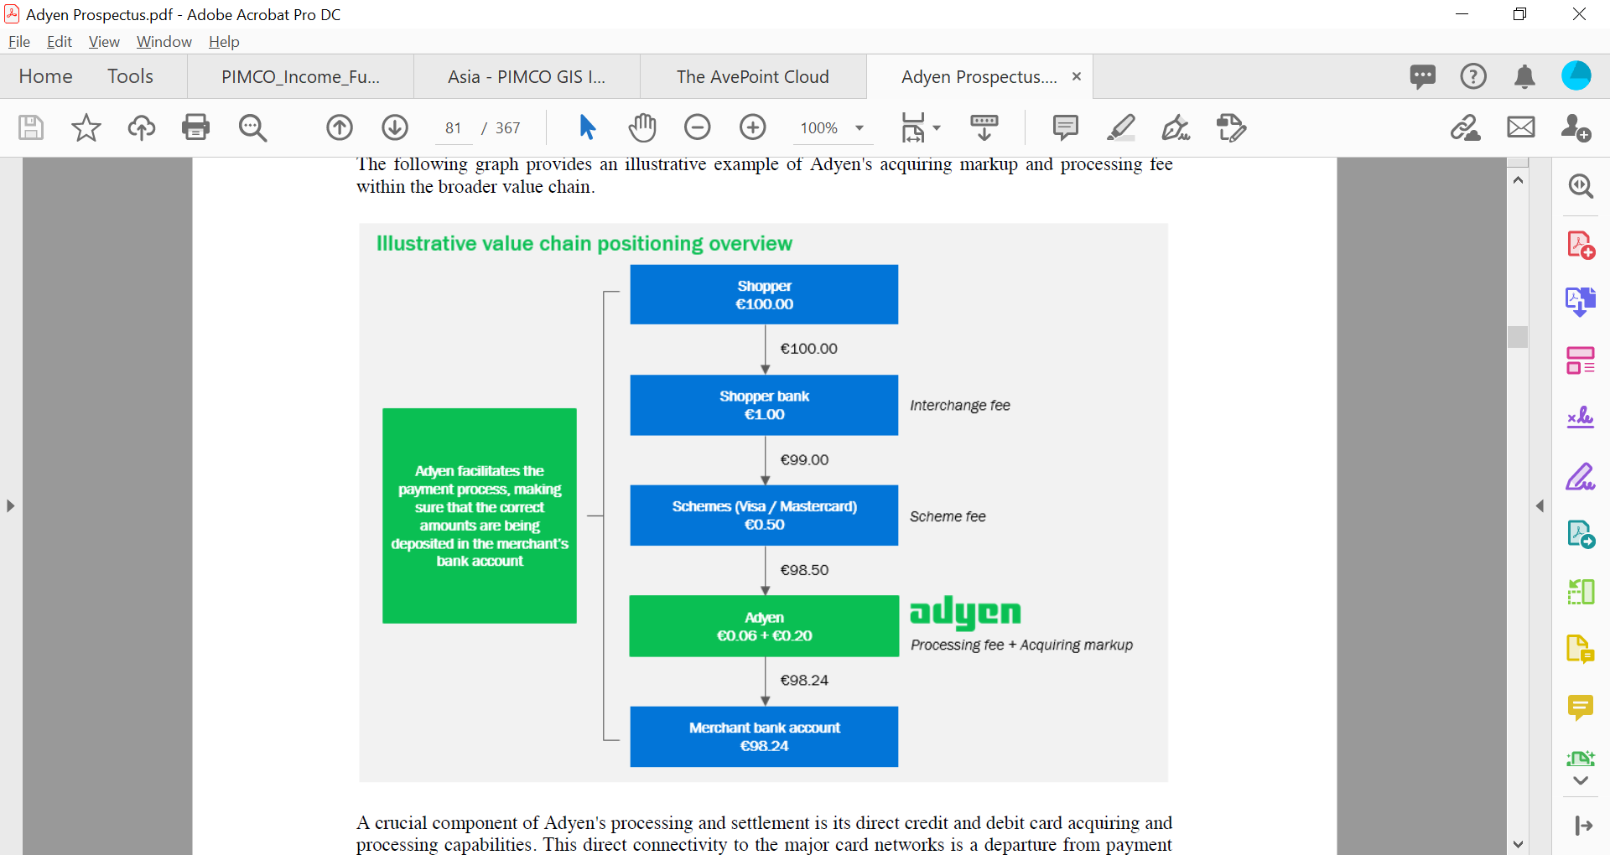As you can see above that typically for every Euro processed, Adyen ends up keeping around 1 cent before gross expenses and 0.17 cents after. So it’s quite obvious that this payment processing is a low-margin game, which requires huge volumes to make the business work, and while Adyen has achieved such high-volumes they also have secondary business including PoS systems (for physical retail) as well as new initiatives into the card issuing space that help boost the top line.

**Why Customers Love it:**

Adyen claim that one of the key reasons for its success is that the industry has a very fragmented view of payments data. This is because legacy systems, each part of the process stores data separately, but when you combine all those parts into 1-step (Ie the Adyen platform) data can be harnessed and increases opportunities for merchants to adapt their offerings and maximise their earnings. This also allows Adyen to be better able to detect fraud (when they know more about buyer patterns), and strengthens their own solution.

One of the key things that we’ve heard from Adyen’s clients, and the reason they chose Adyen over competitors is because of Adyen’s ability to offer cross-border and regional solutions (Even though we’ve heard that their tech stack may not be as powerful as their closest competitor, Stripe). Further we’ve also been told that Adyen’s customer service and sales are more hands on than their competitors via constant engagement and do indeed provide a lot of data on buying patterns. Adyen is also more flexible than some of its competitors, and are able tailor solutions for needs of customers (especially in SEA where they are growing their book). This strong customer relationship is illustrated by the fact that 80% of Adyen growth comes from existing customers[6].   
  
Now one interesting thing to note, that could be a risk to this thesis (with regards to churn) is that large tech companies where a user transacts multiple times a month (like a ride-hailing app) are very much considering building some of the connections internally. This is because if they can save say just 20bps on the overall transactions, over billions of dollars of transaction values this adds up to a lot. Now there are two mitigants here (also mentioned by customers) 1) A company that perhaps engages with a customer payment once a month (ie Spotify or Netflix) is unlikely to bother 2) Covid has whipsawed a lot of companies who now have to conserve cash, so those who had projects that were mid-way into creating their own links to the payment ecosystem might abandon them or those who had plans will not pursue them, and these companies will rely on Adyen taking care of it.   
  
In our research we’ve also heard competitors speak praises of Adyen. When speaking to a product manager of competitor, we were told that there are a few ways Adyen has done really well in the space 1) Superior tech (confirmed Adyen/Stripe have some of the best tech) and 2) Clear focus on enterprise customers (where as some of the other competitors try to go after everything).

**Current business:**

There are a few lines of business that Adyen currently operates.

* Online payments – which is a bulk of their revenue – in an off the cuff comment, the CEO of Adyen, Pieter van der Does stated that “80% of Silicon Valley” uses Adyen to process their payments. In 2019 80% of growth came from existing merchants, and volume churn was below 1%[7].
* Point of Sale – for physical retail, Adyen partners with Verifone to provide retailers with physical PoS Devices. Adyen records the sale of the PoS system, but in 2019 this was a loss making venture as the Sale of Goods line item was less than the cost of inventory. While Adyen does collect terminal service fees for this, the true value of this business is to capture more of the payment ecosystem. In 2019 point-of-sale volume made up 12% of all payments.
* Platforms – For services like e-commerce which require multiple users paying in, and multiple vendors require payouts. Customers include Ebay, Etsy, Uber, gofundme, etc. Revenue for this is accounted for within Settlement and Processing Fees line item.
* Unified Commerce – tackling end-to-end solutions for clients who have offline and online business. Here Adyen partners with Aptos, Salesforce, Oracle Retail etc to provide omni-channel reporting. This is a particularly exciting growth area for the company, and in 2019 they inked deals with Subway and McDonalds to help them with in-restaurants, online, and in-app purchases.
* Issuing – Allows customers to create and issue virtual or physical cards. This is a relatively new business and while Adyen speaks to high long-term opportunity, they have given few details on progress. However it seems that the cards will be debit in nature (so no credit risk), and revenue will be earned via a revenue share with the merchant.

**Company Culture:**

Throughout our research we kept coming across the cultural aspects of Adyen which caused us to think that this was an important aspect of their culture that point toward long-term thinking, equality, and high-general employee satisfaction. Below we’re going to list out aspect of the company that we think are unique the company culture and worth exploring.

* Zero acquisitions – the company refuses to acquire other payment business as they find it’s too difficult to merge tech-stacks, and instead of making the process simpler (which is their goal), acquisitions make the stack more complex. Further, merging of variant company cultures never seems to pan out (in Pieter’s opinion)[8]. There is zero ‘goodwill’ on their balance sheet.
* All tech is built in house, and they don’t do customization for clients that won’t benefit other clients as well. They build to benefit all merchants, not just one. One can imagine this allows for rapid scaling.
* They are very slow to hire (and got a lot of flak for this), and everyone who joins needs to interview with a management board member as a final step. Culture is very important to them, and they would rather higher for fit than talent. Further there is just one type of share-class.
* They highlight a number of cultural traits in their mission statement including, “Winning is more important than ego; we work as a team – across cultures and time zones,” “we don’t hide behind email, instead we pick up the phone” and “we talk straight without being rude”[9]. All this seems to point toward a culture of meritocracy and low bureaucracy.
* They only have 1 PnL, they do not have PnLs by geography/business groups, which drives people to collaborate internally rather than compete.

Now we have seen and worked for companies that espouse certain traits, but as you can see from above, a lot of the ‘talk’ is ‘walked’ (no acquisitions, platform built for scale rather than customisation). Further, looking at Glassdoor reviews, it does seem that the company has created something special with reviews highlighting freedom, responsibility, and a flat hierarchy.

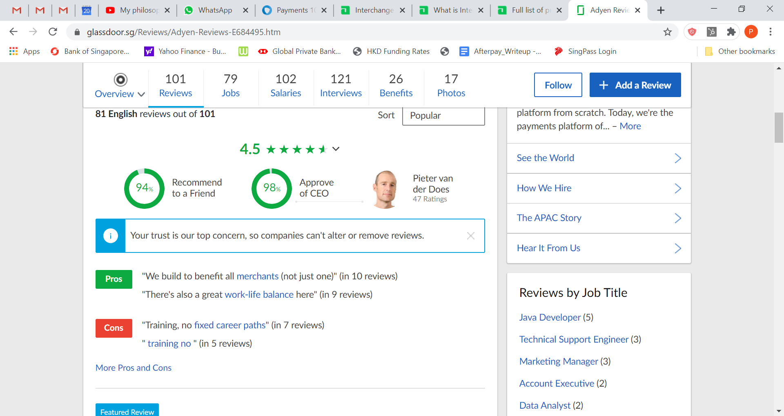

Now one might dismiss ‘culture’ as a bit intangible for stock analysis, however culture can be a moat in itself. The stronger your company culture, the better talent you attract, the better talent you attract, the better product your produce, the better product you produce, the higher top-line you have.

As per their IPO prospectus, Adyen believes that the "Adyen Formula" is a “key driver in enabling Adyen's ability to hire and retain top talent, to foster the Adyen culture and to have fun while changing the payments industry.” This has been driven by the founding team, whose members have worked together for 15 years, and continue to work together, and plan to be a part of the company (and significant shareholders of the company) for the foreseeable future.

**Competition:**

We believe that Adyen’s key competitors are Stripe and Checkout.com (both of which are privately held for now) which have similar products and customer base. Paypal is also a competitor via Braintree, but our checks with customers illustrate that Paypal was neither innovative enough nor was their tech strong or solution localized enough. Other incumbents include Worldpay (owned by Fidelity National Information Services), Cybersource (owned by Visa), Ingenico, Mastercard Payment Gateway Services.

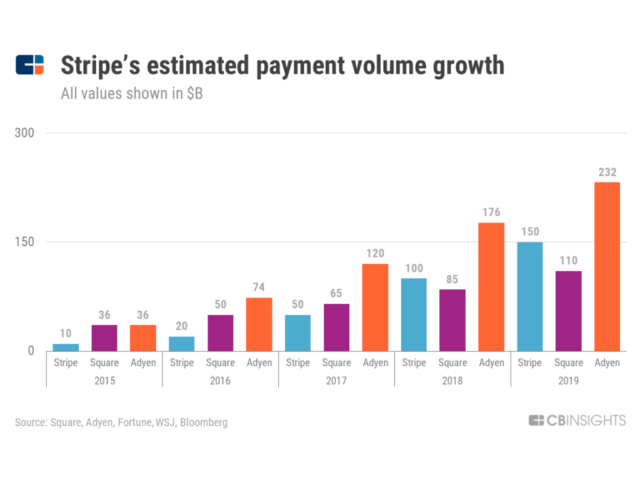

The above chart shows Adyen as bigger with regards to processing payments than Stripe, and although Stripe is growing faster, it is earlier in its journey. (The graph also shows Square, but Square’s payment solutions are usually embedded in their other merchant solutions, and do not compete in the enterprise space).

***Adyen vs Stripe:***   
  
Both Adyen and Stripe are very similar in nature. Both run by their co-founder, founded in late 2000’s, and innovative in the payment space, and compete quite head-on (some companies will use one service for certain countries and the other for other countries, all within the same region). Now our understanding from customers is that their solutions can be a bit homogenous (although Stripes tech might be a bit better and more open), and it’s really in the sales process that they differ. As put very well in this blog post *“To paraphrase a conversation I had from a decision maker that had recently experienced a sales presentation from both Stripe and Adyen: Stripe seems interested in everything but the payment processing component. Adyen is solely focused on the payment processing experience. Stripe talks a lot about “growing the GDP of the internet” and is focused on offering a broad suite of services to wrap around the core payment experience”[10]*

Because Stripe aim is to help everyone, they have a stronger foothold over the SMB market, where as Adyen has largely stayed focused on the Enterprise segment. Stripe has a more laid-back approach, with no real sales team where as Adyen focuses on a more traditional go-to-market enterprise strategy. As one of our conversations with a customer of both companies put it “*Adyen is more white glove, and Stripe is more call us when you need help.”* In the end we don’t see this as a winner-take-all market, in fact customers have told us they will typically use both Stripe and Adyen in order to have some negotiating power over fees. We do believe that both Adyen and Stripe being excellent companies worth investing in (i.e. the new generation Visa and Mastercard). With so little of world’s commerce online[11], there is room for both to grow exponentially.

The last valuation, put Stripe at $36billion (April 2020[12]) and while they do not reveal revenue and transaction volume numbers (even the chart above is a guess) one would assume that volumes are somewhat similar to Adyen’s.

***Adyen vs Paypal:***

The competition between Adyen and PayPal is best described via the competition they had with eBay. As most readers would know, PayPal was bought by eBay in 2002, and spun off as its own entity in July 2015. During this time PayPal signed a 5 year agreement with eBay to allow it to continue serving as its payment processor. In 2018, eBay announced that when the agreement expires (July 2020) that they would not be renewing it, and instead moving to using Adyen. eBay did this as they wanted to “further improve its customer experience by intermediating payments on its Marketplace platform. In doing so, eBay will manage the payments flow, simplifying the end-to-end experience for buyers and sellers.[13]” eBay also stated that this new partnership would allow merchants to have a more central view of their data and to manage and track all interactions. This correlates well with Adyen’s consistent pitch toward giving the seller more data and making the whole payment ecosystem more transparent, features that PayPal could not seem to provide (also at the time users had to sign up to a PayPal account to complete transactions).

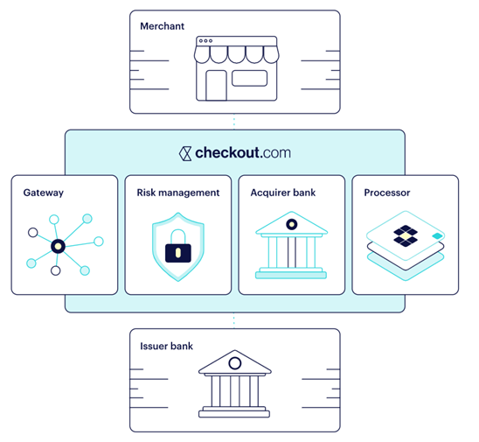***Checkout.com:***

Checkout is a new dynamic company based out of the UK, which seems to focus on two things very clearly 1) Fraud prevention (as highlighted by whitepapers on their site) and 2) Direct links to the banks. In our thinking the second part of their value-prop (direct links to the banks) is really quite smart as it helps save merchants the fees that they pay to Visa/Mastercard (or any card network) – see diagram on the side. Now obviously this means that this would be a direct payment from the users bank account to the merchant (as use of any card would require the network fee), but as we see younger generations use debit more than credit, this might be quite a viable solution for many merchants. As one merchant put it to us “*if you’re doing billions of dollars in payments a year, even 10bps adds up to a lot.”* Checkout.com is earlier in its evolution, founded in 2012 and last valued at $5.5 billion, but seems to be one of the next big IPO candidates.[14]

*Summary on Competition:*

There are a number of players in the space such as Rapyd (focused on cross-border payments, especially in APAC), GoCardless (focused on direct debit payments), Square (focused on SME space via physical retail and ecommerce solutions). Given the complexity of the payments space we wouldn’t be more surprised to see more competitors trying to jump in, each trying to solve a piece of the puzzle, or focusing on a certain niche. That said, given Adyen’s foothold, brand, tech stack, and focus purely on payments, we do feel that they will continue to be one of the industry leaders for years to come.

**TAM:**Now that we’ve discussed the competition, and explained that there are a number of players, it might be worth us taking a look at why multiple-competitors do not matter. The key here is to truly identify the TAM (Total Addressable Market) which each of these players is trying to access. To do this we have to dig a bit deeper into what the true TAM here is. Now this is a bit tricky as we have to essentially understand what the size of the digital economy is (remember we can’t just simply take e-commerce numbers as that wouldn’t be representative of Adyen customers). We haven’t found a good dataset to start to understand TAM, so we’ve tried to come about it from a bottoms up-basis[15].

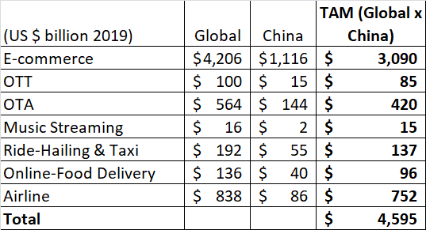

We’ve removed the China numbers from the global numbers as the Chinese payment ecosystem is quite unique, and not necessarily one where foreign players should expect to get much of a foothold. However even then, we see that we’re looking at a TAM of nearly $4.5 trillion (and this is only looking at some of the larger online industries). If we combine some of the larger players we see there are still lots of room to grow for all of them.

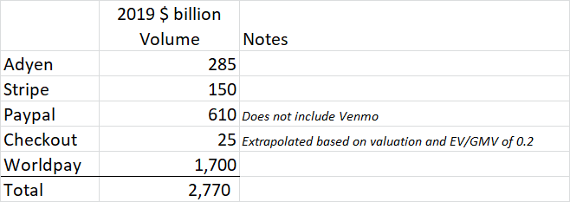

We know this is quite rough, as there are dozens of players on the online space. We’ve also left out a lot of legacy players here, and only included Worldpay. The reason we did this is to establish one major point. If we take out Worldpay from the above, we notice that the new players only deal with about a trillion dollars in volume. If we are correct with our TAM estimations that implies that 4-5 trillion is still being managed by legacy players (like Worldpay, Ingenico etc). So the market does not even have to grow for companies like Adyen to do well, as all they need to do is take marketshare from the legacy players. When reading a transcript with a previous Worldpay exec we noticed that the exec mentioned that a company like Adyen, even now barely cracks the top ten payment processors globally by volume. Thus there is lots of room to grow, and given Adyen’s better tech stack than legacy players, it shouldn’t be a hard battle to win.

Further, we haven’t even talked about growth yet. A UN report states that the internet economy is only about 4.5-15% of the Global economy (which is ~$184 trillion)[16]. So we expect this number to continue to increase as internet penetration grows. Just as an example, data from ShawSpring Partners showed that US e-commerce penetration is only ~27% of total retail, and this is after the coronavirus-driven boom.

Further in our TAM we haven’t included B2B paymnets (which is nearly $17 trillion) and offline payments which are key to the business strategy for companies like Adyen (and could get bigger should they bring over Wirecard’s customers[17]). The offline space has its own set of players including traditional acquirers, Square (which does $100bn in volume), Igencio, Worldline, and Nets. What we are trying to present is that there are mounds of opportunity for growth, and the key to success will be a combination of an excellent tech solution and top-class customer solutions and service.

**Financials:**

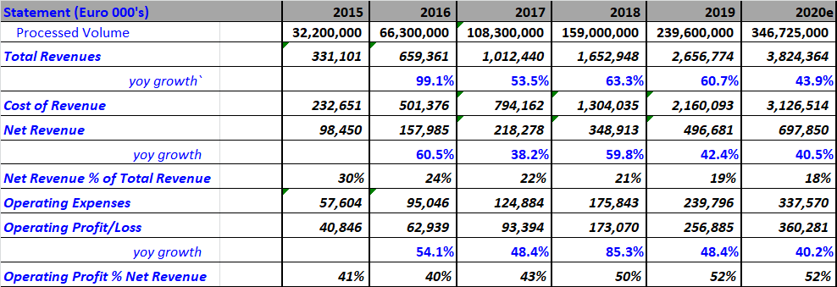

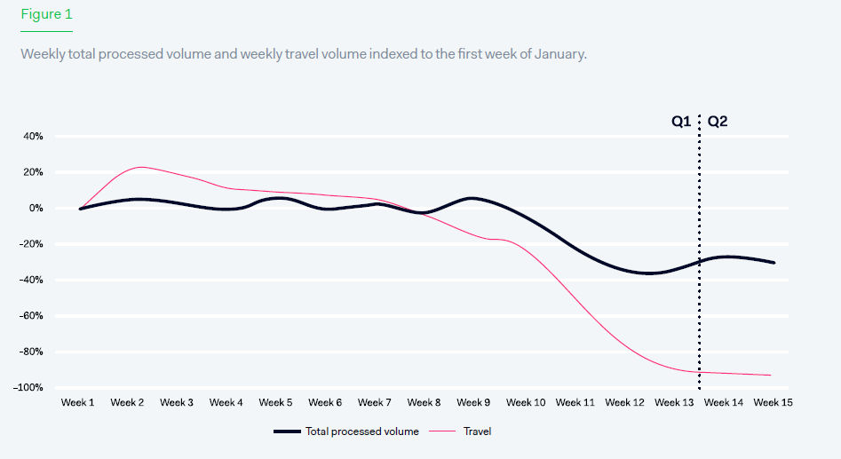2020e numbers will be highly affected by how well Adyen captured the boost of coronavirus. They had released a mid-season report (as was typical with most companies due to the pandemonium in March), which showed that while volumes were up 38% yoy, volumes were down as compared to January.

Thus we are conservative in our approach and only expect a 44% growth in volumes in 2020. Upsides here include faster than expected growth via eBay (set to kick in during second half of 2020) and travel bookings returning.

Adyen has no debt, and generated a little over Euro 500 million in free cash-flow in 2019. Over the medium term Adyen hopes to grow its net revenue at a CAGR of between mid-20s to low-30s, and expects long-term EBITDA margin to stay above 55%, with capex remaining at 4-5% of revenues.

On the expense side it should be noted that Adyen has been ramping up its FTEs by 35% in FY19 and we expect them to do similar in FY20. Management has commented that this growth in employees is to be able to handle more customers and support merchant growth.

*Revenue Breakup:*



**Valuation:**  *Relative Valuations:*



The relative valuations shows that on a total volume basis Paypal is more expensive than Adyen, but due to the nature of some of that volume (Paypal B2C or B2B volume would not go through the traditional payment ecosystem), it has a much higher net Revenue, thus making the payment volume more valuable. But it’s important to note that Adyen is growing much faster than Paypal. Further it seems that Adyen is much more efficient business with OI as a % of Net Revenue of 51% versus 32% for Paypal. Overall it seems that if the market is pricing Paypal correctly, than on a relative basis, Adyen’s valuations look inline.

*DCF:*

A DCF using a beta of 1.27, WACC of 8.71, and FCF growth of 45% in the first year, declining all the way to 15% in the 10th year, and a 12.4x exit multiple, gives us a market cap of Euro 46.27bn which is a slight premium to the current market cap of 44.815bn. So this would very much qualify as a growth at a fair value type of situation.

**Management:**  
The Exec team is headed by founders Pieter van der Does (CEO) and Arnout Schuijff who receive Euro ~523K and 261K Euro in compensation respectively in 2019 (Arnout works part-time). Their compensation is almost entirely base salary. As of end 2019 they held 1.202 million and 1.613 million shares respectively which was the equivalent of 4% and 5.2% of the company (making them multi-billionaires). While they have sold some shares since IPO, they still retain around 75% of their IPO holdings. We have been told that the founders are very down-to-earth, ride bikes to work, and live in small apartments despite their wealth.

**Risk:**

*Regulation:* There are select business model risks to this thesis as each country brings its own unique issues that can lead to additional costs or a loss of revenue. For example, India banned payment companies from charging the Merchant Discount Rate. However as the business gets more diversified, its less beholden to any one country or one regulatory regime.

*Competition:* We’ve talked a lot about the number of competitors both on the offline and on-line space, as well as competitors that are focusing on certain niches. While competitors will come and go, we are comforted by Adyen’s less than 1% volume churn, and focus on customer relations. As Pieter has been quoted saying “We don’t lose customers to anyone[18]” That said, there is some risk that large companies with frequent payments

*Travel exposure:* While Adyen does not break out industry exposure, it does seem that they have quite a few airline customers including Singapore Airlines, Cathay Pacific, KLM, GOL, etc. It goes without saying volumes from this industry will be subdued for quite a while, so this could impact growth for 2020 and likely first half 2021.

**Thesis:**

It’s rare to find companies that are growing rapidly within industries that are growing rapidly, all while being profitable and cash flow positive. While there are a number of competitors Adyen should continue to be a winner based on

* Superior tech stack and customer service
* Growth of share of wallet of current customers and new customers
* General tailwinds as payments move online and customers look to have a 1 stop shop solution
* Excellent management and solid culture

1. [Tech Chill 2019](https://www.youtube.com/watch?v=KPDez52PAq0)
2. H22019 Earnings transcript
3. <https://www.thehindubusinessline.com/opinion/columns/slate/all-you-wanted-to-know-about-the-zero-mdr-issue/article30559534.ece>
4. “Invest like the Best” Podcast, June 16th 2020, Feat. John Collison
5. <https://www.adyen.com/blog/interchange-fees-explained>
6. H2 2019 Earnings call
7. <https://seekingalpha.com/article/4328555-adyen-n-v-adyyf-ceo-pieter-van-der-on-h2-2019-results-earnings-call-transcript?part=single>
8. [Empowering Innovators:](https://www.youtube.com/watch?v=yGEwgBuUkw8)
9. [Tech Chill 2019](https://www.youtube.com/watch?v=KPDez52PAq0)
10. <https://www.spreedly.com/blog/stripe-vs-adyen>
11. According to Shawspring partners, they think e-commerce of total commerce spend is still less than 30%.
12. <https://www.cnbc.com/2020/04/16/stripe-raises-600-million-funding-round-at-36-billion-valuation.html>
13. <https://www.ebayinc.com/stories/news/ebay-to-intermediate-payments-on-its-marketplace-platform/>
14. <https://techcrunch.com/2020/06/22/checkout-com-the-uk-payments-startup-raises-another-150m-now-valued-at-5-5b/>
15. <https://www.oberlo.com/statistics/global-ecommerce-sales>, https://www.statista.com/outlook/243/117/ecommerce/china

    https://www.streamingmedia.com/Articles/ReadArticle.aspx?ArticleID=140914

    https://kr-asia.com/largest-chinese-ota-ctrip-managed-to-grow-in-the-face-of-heating-competition

    https://www.statista.com/outlook/209/100/music-streaming/worldwide

    https://www.statista.com/outlook/368/100/ride-hailing-taxi/worldwide

    https://www.statista.com/outlook/368/117/ride-hailing-taxi/china#:~:text=Revenue%20in%20the%20Ride%2DHailing,to%20hit%2041.5%25%20by%202024.

    https://www.statista.com/outlook/374/100/online-food-delivery/worldwide

    https://www.statista.com/statistics/278372/revenue-of-commercial-airlines-worldwide/#:~:text=Globally%2C%20commercial%20airlines%20generated%20combined,billion%20U.S.%20dollars%20in%202019.

    https://www.ibisworld.com/china/market-research-reports/airlines-industry/
16. <https://unctad.org/en/PublicationsLibrary/der2019_en.pdf> (4.5% is low end, 15% is high end if you include smart products etc).
17. <https://www.reuters.com/article/us-wirecard-accounts/police-raid-wirecard-hq-as-administrator-kicks-off-asset-sales-idUSKBN2424H3>
18.